**Assignment 5 – Adding Functionality to a Website with JS**

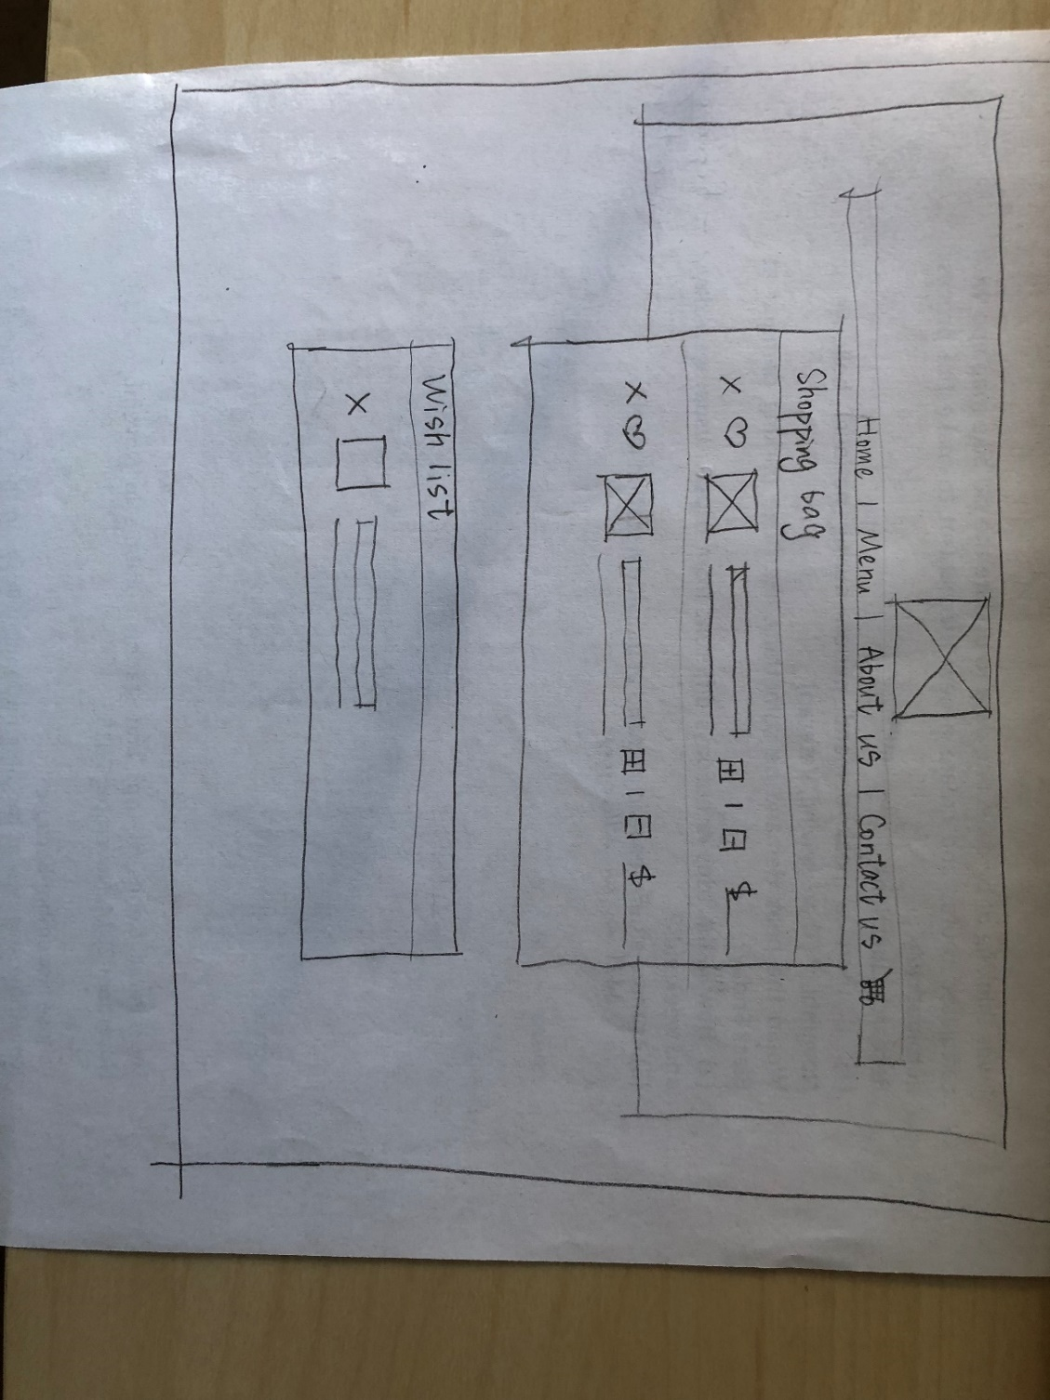

Figure 1 Shopping cart page low- fi

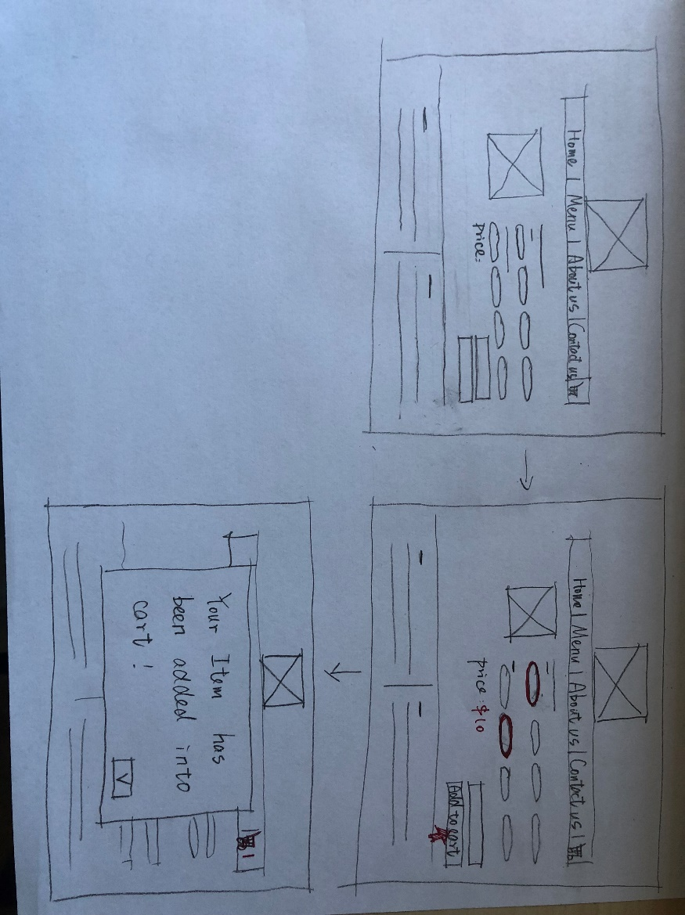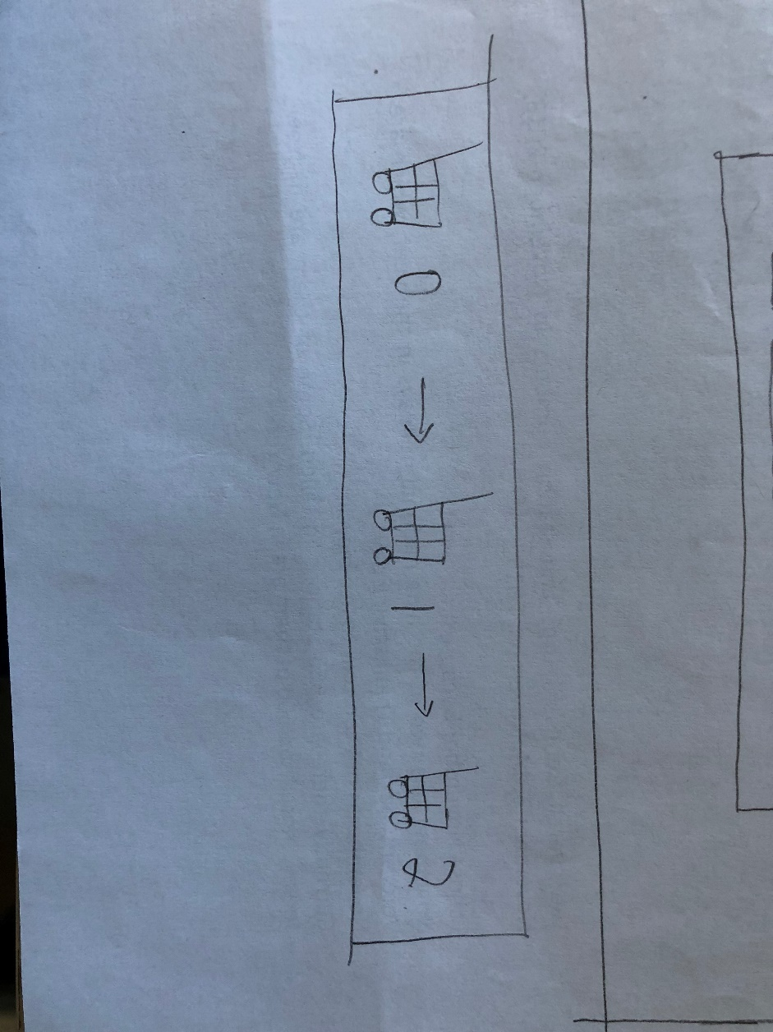

Figure 2 When user select on detail page

Figure 3 visual indication of shopping cart change

**Design Choice:**

For detail page, users can clearly see what has been selected by using check box, when users click add to cart button, a prompt will reminder them items has been added.

For shopping cart page, the basic idea is to put shopping cart and wish list on the same page so that users can toggle in between easily. Both shopping cart and wish list will show a thumbnail of the product to fulfill the design principle (recognize rather than recall). Users can click the heart logo to put items into wishlist, which is a well- known design pattern that has been used for many popular retail sites so far.

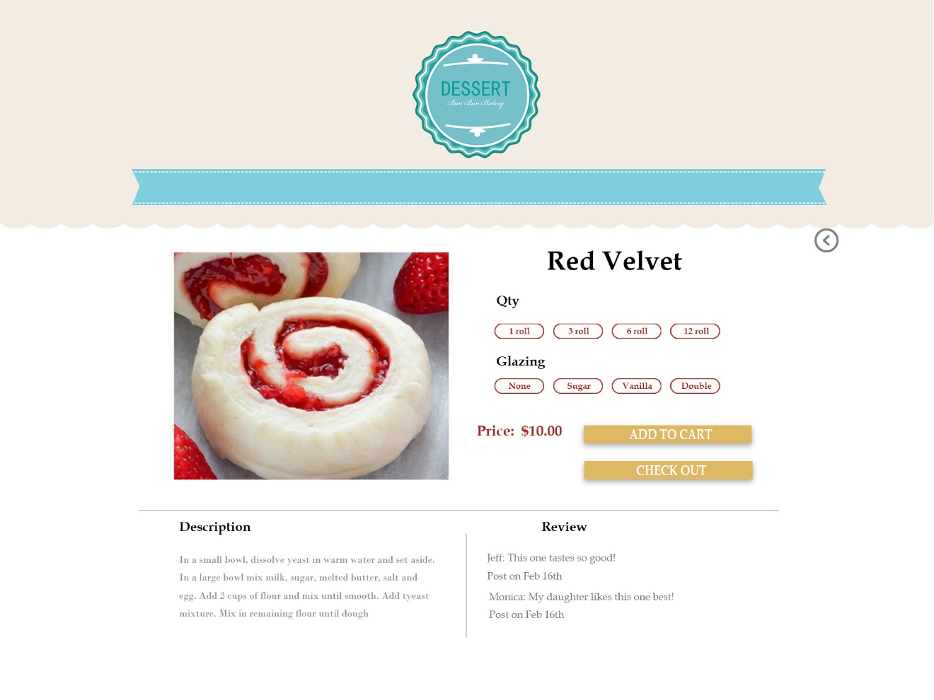

Figure 4 detail page change by user selection

This is the same page from last homework, differently, now when user selects qty and glazing, it will generate a new price for that and when user click add to cart button, a prompt will pop up to reminder you that your product has been put into the cart.

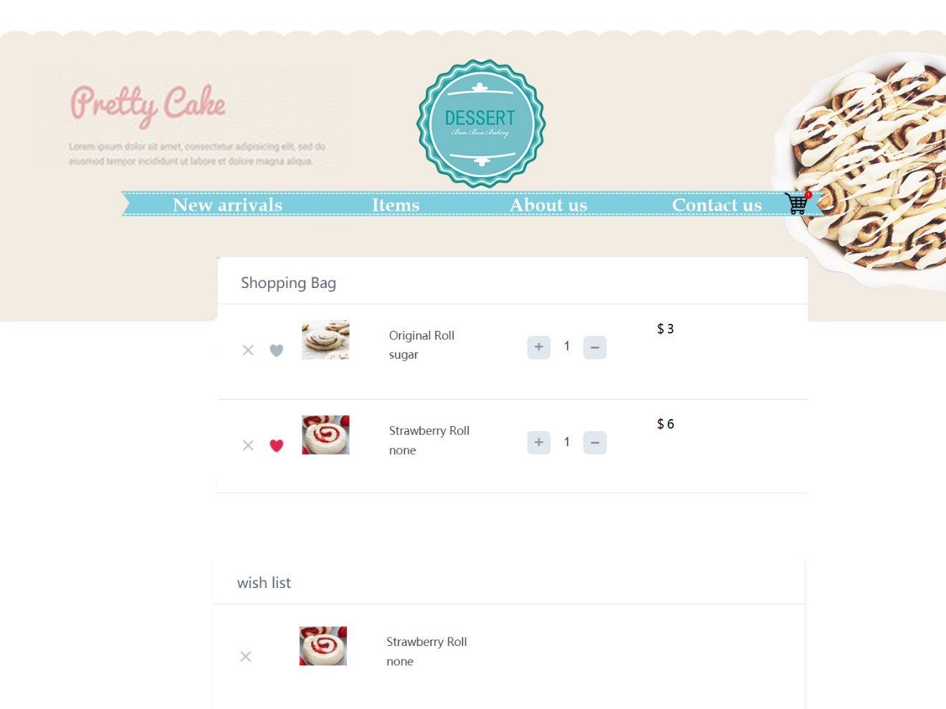

Figure 5 Shopping cart page high- fi

**Design Choice:**

When user clicks the shopping cart logo on the right up corner, it will jump to the shopping cart page. At this time, the logo will display how many items are there in the cart. Click the “×” widget to delete current item, “♥” to add the current item to wish list.